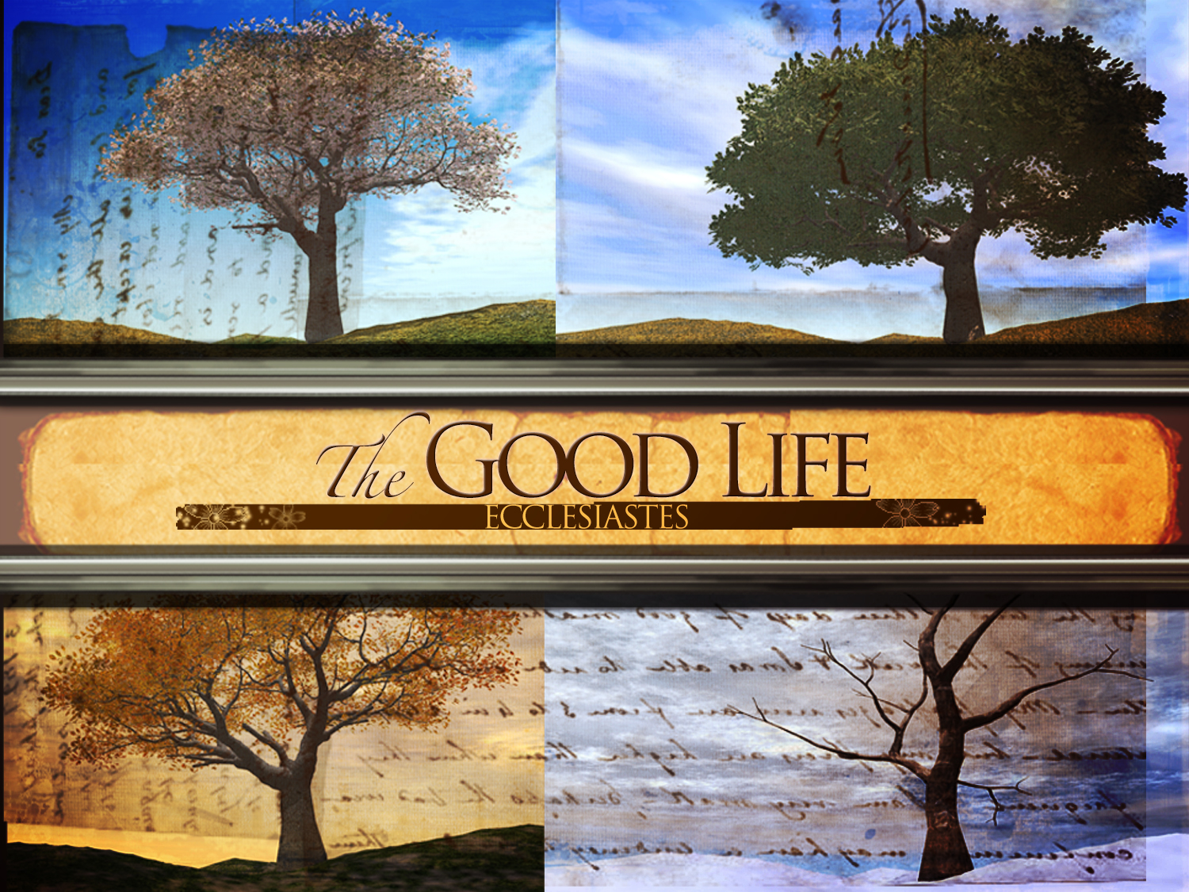
“All is Vanity”
1st in the “Life is Good” Series
Text: Ecclesiastes 1:1-11 pg. 553
January 8, 2017
Pastor Mickey Klink

7) The Preacher seems to be saying in vv. 4-7 that we think we are
accomplishing something, but in reality nothing changes. How accurate is
this description to human life, even your life?

8) The Preacher seems to be saying in vv. 8-10 that we never find satisfaction
and are always looking for the next, new thing. How accurate is this
description to human life, even your life?

9) How does this text want us to stop pretending (or believing the lie) that what
is mortal is truly satisfying?

10) If you were honest with yourself, what have you conceived to be the Good
life? After reading the introduction to Ecclesiastes, how do you think this
book is going to explore that question?

PRAYER REQUESTS:
__________________________________________________________________________________________________________________________________________________________________________________________________________________________________________________________________________________________________________________________________________________________________________________________________________________________________________________________________________________________________________________________________________________________________________________________________________________

Introduction

Introduction
In this passage we are introduced to Ecclesiastes and the meaninglessness of life without God.

The Text: Ecclesiastes 1:1-11

- A Brief Introduction to the book of Ecclesiastes

- God teaches us that everything is meaningless and fleeting without him (vv. 1-2)

- Experience teaches us that there is nothing on earth that will truly satisfy you (vv. 3-11).

Response

- He who dies with the most…., still dies!

Would you like to be involved in a Small group? Contact Pastor Brad at pastorbrad@hefc.net
All is Vanity
Ecclesiastes 1:1-11

- Read the text aloud and discuss together any significant observations or issues needing clarification.

- How does understanding the genre (or type of literature) of a biblical book help in the task of interpretation?

- What are some of the traits of biblical “wisdom literature” that would be helpful to note for proper interpretation? How is Ecclesiastes handled differently than Acts (historical narrative)? Let books like Proverbs and Song of Songs be used as analogies.

- Read 1 Kings 4:29-34. Why do you think the God choose Solomon to be the voice of Wisdom not only in Ecclesiastes (v. 1) but also Proverbs (1:1) and Song of Songs (1:1)?

- Solomon is described as “the Preacher.” How does this description affect the way the message of the book is perceived, or to be received?

- V. 2 introduces the theme of the entire book: “All is vanity” (or meaningless, pointless, a breath). How do vv. 3-11 explain that life is vanity?

