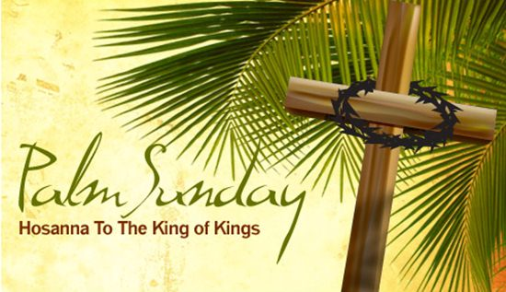
“Palm Sunday”
Text: Luke 19:28-40
April 9, 2017
Pastor Mickey Klink

7) What might be the significance of the phrase in v. 30: a colt “on which no
one has ever sat?” Remember, God is not unintentional with such
statements.

8) There were no political officials on hand, and the religious officials only
came to rebuke King Jesus (see v. 39). How is this entry into Jerusalem not
quite as “triumphant” as the Second Coming will be?

9) Read 1 Thessalonians 4:15-18, noting especially that the phrase “caught up
in the air” refers to the royal greeting the world will give to Jesus, literally
lifting up to meet him as he arrives and return with him to the earth. Why is
the greeting in 1 Thessalonians so different than the one in Luke 19?

10) What, then, is the ministerial purpose of Palm Sunday, or the reasons why
it is good to celebrate it annually?

11) How does Palm Sunday help you prepare for Good Friday and Easter?
How does Palm Sunday point you to and help you reflect upon the gospel?

PRAYER REQUESTS:
__________________________________________________________________________________________________________________________________________________________________________________________________________________________________________________________________________________________________________________________________________________________________________________________________________________________________________________________________________________________________________________________________________________________________________________________________________________

Introduction

Introduction
Through this passage we will examine the purpose of Christian holidays and especially Palm Sunday.

The Text: Luke 19:28-40

- What is Palm Sunday and why does Hope Church acknowledge it at all?

- Does Hope Church celebrate the church calendar?

- What, then, is the ministerial purpose of Palm Sunday (Luke 19:28-40)?

- It directs us to look closely at the person of Jesus, that he is the King (vv. 28-35).

- It directs us to look closely at the reception of Jesus, that he is to be rightly received (vv. 36-40).

- It directs us to think more deeply and personally about the gospel Jesus offers to us and which we especially celebrate this week.

Response

- Let us be formed by the sacred week we have now entered on this day, Palm Sunday.

Would you like to be involved in a Small group? Contact Pastor Brad at pastorbrad@hefc.net
Palm Sunday
Luke 19:28-40

- Read the text aloud and discuss together any significant observations or issues needing clarification.

- Your familiarity and understanding of Palm Sunday is probably based on the length of your Christian life or the theological exposure you have received. How would you describe the history behind Palm Sunday and its ongoing purpose for the church?

- Have you heard about the church calendar (or liturgical calendar) before? What is your understanding about the church calendar and the worshipful celebration of Christian holidays?

- How would you explain these Christian holidays to a non- or new Christian: Advent, Christmas, Epiphany, Lent, Holy Week (Palm Sunday, Maunday Thursday, Good Friday), Easter, Pentecost, Reformation Sunday?

- Christians differ on the value of practicing these Christian holidays. What are some biblically-defined principles we can use to determine the use and value of such holidays for the life of the church and the Christian? How does Hope Church practice such principles?

- The detailed preparations for Jesus’ entry into Jerusalem are clearly important to the narrator because they are loaded with OT significance that explains the identity of Jesus. How does Zechariah 9:9 provide the context needed to explain how Jesus viewed his entrance?

